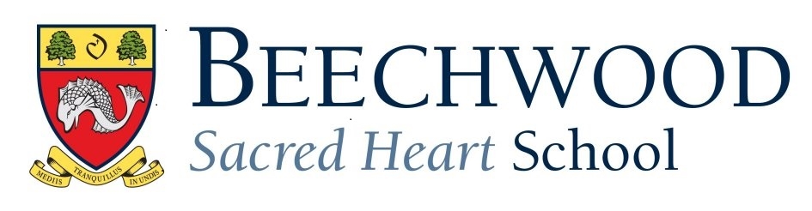
Opening Plan for September 2020
Parent Handbook
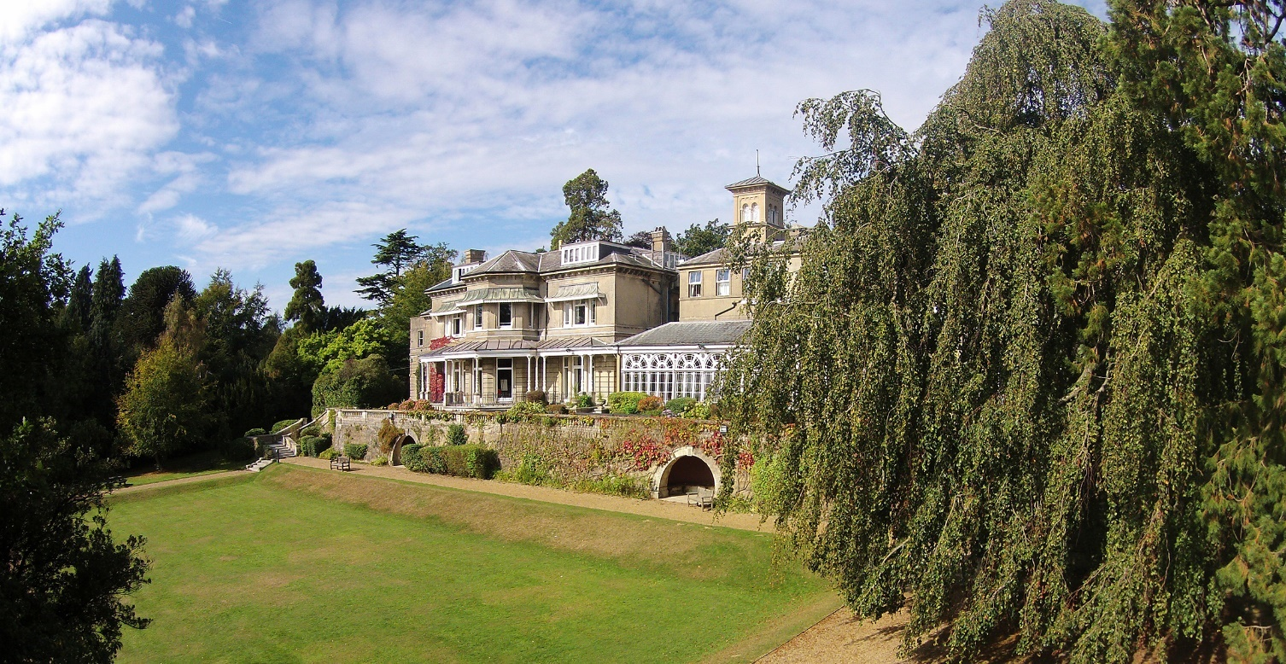
v.1 18th August 2020

Introduction
Dear Parents,

I hope you and your families are safe and well. It seems an age since the Government announced the closure of schools back in March, and after the long summer holidays, we are delighted and feel eager to welcome back all our pupils full-time on Thursday, 3 September.

Considerable planning has been going on over the summer to ensure the return to school is as safe as possible for pupils, staff, and families. We can expect several changes to our normal routines, but I have no doubt we will quickly adapt just as we have in other areas of our daily lives.

Much like the varied approaches adopted in different regions of the UK, you will find the way schools have implemented the guidelines will differ slightly because of their individual circumstances. We appreciate the challenge this presents for those families with siblings at other schools because the differences can be confusing. However, we hope this comprehensive booklet brings clarity on how Beechwood Sacred Heart will adapt. We would be grateful if you read the contents carefully and discuss the relevant sections with your children. We will, of course, reinforce the key messages with the pupils when they are in school: frequent washing of hands, social distancing, keeping to bubbles, and the now well-established approach to sneezes and snuffles of ‘catch it, bin it, kill it’.

We have aimed to implement control measures that are balanced, measured, and follow the fundamental set of principles laid down to minimise risks as described in the Government guidance. These measures require everyone to play their part to be effective, and I would like to thank you for keeping to the guidelines in this handbook.

It is most important that your child doesn’t attend school if they are unwell, or if a member of your household is displaying symptoms. Equally, if your child falls ill during the day, we ask that you collect them swiftly from the school. I appreciate the logistical challenges it may cause to collect your child during the school day but thank you, in advance, for helping us to maintain as safe an environment as possible for everyone.

We will continue to monitor and review these arrangements and will follow any new guidance as it emerges. While we believe the handbook covers all the key areas relevant to parents, you may have questions about aspects not covered here. Please don’t hesitate to ask if there is something you wish to clarify, and if there are several similar questions, we will send a summary to keep everyone well-informed.

We aim for a smooth and safe return to school and look forward to being together as a community once again in September. As the new Head, I look forward to meeting you all and am excited for the start of the new academic year. While it will be different, I am confident the new routines will quickly become good habits, and while some aspects of the school day will out of necessity be different, we will be working hard to devise safe, pragmatic ways to work around the issues and enable our pupils to enjoy as many normal school activities as possible.

Kind regards,
Nick Waite
Headmaster

How everyone can help make schools and colleges as safe as possible
Beechwood Sacred Heart School has conducted a health and safety risk assessment as part of their planning for the autumn term and the return of all pupils.
As part of this, there are certain approaches that the government has asked schools to implement which are essential to reduce health risks. Parents and carers can support this by:
- ensuring that anyone who has coronavirus (COVID-19) symptoms, or has someone in their household who does, does not attend school - this means if your child, or someone in your household, has symptoms you should not send them to school
- engaging with the NHS Test and Trace process so that cases can be identified and action taken - this means if your child develops symptoms, you should arrange for them to get a test and you should inform the school of the results of that test. Positive tests will require the pupil to self-isolate and not attend school. Negative test results will need to be discussed in person with the School Nurse.

https://www.gov.uk/government/publications/what-parents-and-carers-need-to-know-about-early-years-providers-schools-and-colleges-during-the-coronavirus-covid-19-outbreak/what-parents-and-carers-need-to-know-about-early-years-providers-schools-and-colleges-in-the-autumn-term
Alongside this, the government is asking schools and colleges to ensure they are:
- managing confirmed cases of coronavirus (COVID-19) in the school, in line with current public health guidance - this means your child may be asked to self-isolate for 14 days by their school (based on advice from their local health protection teams) if they have been in close, face-to-face contact with someone who has tested positive for the virus
- ensuring everyone at the school cleans their hands more often than usual, including when they arrive at school, when they return from breaks, and before and after eating - this can be done with soap and running water or hand sanitiser
- ensuring good respiratory hygiene, by promoting the ‘catch it, bin it, kill it’ approach
- enhanced cleaning, including cleaning frequently touched surfaces more often
- minimising contact and maintaining distance, as far as possible
- In broad terms, it will involve asking children to stay within specified separate groups (or bubbles), and through maintaining distance between individuals. The government’s guidance to schools recognises that younger children may not be able to maintain social distancing so it is likely that for younger children the emphasis will be on separating groups, and for older children, it will be on distancing.
It will be important that parents help the school to implement these approaches by following the advice set out here and wider public health advice and guidance.
https://www.gov.uk/coronavirus/education-and-childcare

Government Key Recommendations to schools:
Arriving and leaving school or college
We may need to stagger or adjust start and finish times or define different entry and exit points as this helps keep groups apart on the way to and from school, and as they arrive and leave the premises. It will not reduce the amount of time they spend teaching - but it could be that start or finish times are adjusted for your child. We have outlined on page 10 the changes we are making, which includes new processes for drop off and collection. Where possible, pupils should try to avoid public transport, particularly at peak times, and to walk or cycle to school.
Where your child relies on public transport to get to school or college, and cannot walk or cycle, the safer travel guidance for passengers will apply.
https://www.gov.uk/guidance/coronavirus-covid-19-safer-travel-guidance-for-passengers
For school minibus transport, your child will be asked to use a face mask and follow a regular seating plan on this transport (to reflect where possible the bubbles that are used within school), and measures will be put in place to ensure vehicles are cleaned regularly and boarding is managed.
Face coverings are always required on public transport and school minibuses (for children over the age of 11). If your child has been wearing a face covering before arriving at school or college, it will be important that they understand how to remove it. The government has asked schools to have a process for ensuring face coverings are removed when pupils and staff who use them arrive at school. At Beechwood, we would ask parents to ensure that pupils have a resealable plastic bag that pupils can store their face mask.
Children and young people must sanitise their hands immediately on arrival at school or college, dispose of any temporary face coverings they may have been wearing in a covered bin, or place reusable face coverings in a resealable plastic bag they can take home with them, and then sanitise their hands again before heading to their classroom.
Public Health England does not recommend the use of face coverings in schools. They are not required in schools as pupils and staff are mixing in consistent groups, and because misuse may inadvertently increase the risk of transmission. However, we will not stop students wearing face masks in school if they choose to do so.
Curriculum, exams and inspection
Curriculum
The government has set out clear expectations on what schools are expected to teach when pupils return in September. Schools will continue to provide an ambitious and broad curriculum in all subjects. There will be changes to some subjects - such as PE and music - to ensure they can be delivered as safely as possible.
Schools will also make plans for the provision of remote education where needed for COVID-19 cases ONLY, to ensure that the small number of children and young people that need to be educated at home, for example, due to shielding or self-isolation, are given the support they need to continue learning.
Assessment and exams
Following the cancellation of summer 2020 exams (GCSEs, A levels and technical qualifications), the exam boards will be providing students who were due to sit exams this year with calculated grades. In most cases, students will use the grades they receive in the summer to move onto their next step. The government has also announced that there will be an opportunity for students to sit exams in the autumn if they are unhappy with their grades. For those pupils going into year 11 and year 13 from September, the government is planning on the basis that GCSEs and A levels will take place in summer 2021, with some adaptations.
Uniform
We are expecting all pupils to return to their usual uniform requirement in the autumn term. Uniforms do not need to be cleaned any more often than usual, or in any different way to normal due to coronavirus (COVID-19).
School food
The school kitchen will be fully open from the start of the autumn term, and breaks/lunches will be staggered to reflect the allocated ‘bubbles’.
School trips
In the autumn term, we may resume educational day trips, but decisions on this will be based on the nature of the trip, the destination and we will comply with the latest public health guidance and wider guidance for schools on the actions we can take to reduce risks.
Extra-curricular activities
The school will run a breakfast club for Prep pupils. The school will review the extent to which we can offer extra-curricular activities during Phase 1 of re-opening for gradual implementation in Phase 2 or 3. We will need to make sure these can be delivered in line with the wider guidance on protective measures, so we may need to run things differently and adapt over time.
Process in the event of outbreaks
If a school experiences an outbreak, either because they have 2 or more confirmed cases of coronavirus (COVID-19) among pupils or staff in their setting within 14 days, or they see an increase in pupil or staff absence rates due to suspected or confirmed cases of coronavirus (COVID-19), we will need to contact the local health protection team. This team will advise if additional action is required, though the closure of the whole school will generally not be necessary. Where an outbreak in a school is confirmed, a mobile testing unit may be dispatched to test others who may have been in contact with the person who has tested positive. Testing will first focus on the person’s class, followed by their year group, then the whole school, if necessary. If the local area sees a spike in infection rates that is resulting in localised community spread, decisions will be made on what measures to implement to help contain the spread. The government will be involved in decisions and will support the school to follow the health advice. In all cases, where groups of pupils need to self-isolate or where a larger restriction of attendance at school is needed, your child’s education will continue remotely.

Phased Opening: Overall Approach
The school will be opened in three phases during the Autumn Term 2020, with progression from one phase to the next dependent on the effectiveness of measure taken, on the progression of the pandemic, and on any new government or local health guidance.
Autumn Term 2020
PHASE 1 TUESDAY 1st September
Term Starts
Staff INSET Tuesday 1st & Wednesday 2nd September
Senior School: Boarders Wednesday 2nd September 2.00-4.00 pm
Day Pupils/ Term start Thursday 3rd September 8.30 am

PHASE 2 Monday 5th October

Half Term Starts Friday 16th October 4.00 pm
Boarders/Day Ends Sunday 1st November 6.00 pm
Return to school Monday 2nd November 8.30 am

PHASE 3 Monday 9th November

Term Ends
Senior School: Tuesday 15th December 1.00 pm
Preparatory School: Tuesday 15th December 12.30 pm

Phase 1 Characteristics:
- Curriculum and pupil welfare focus
- There will be few, if any, sports fixtures with other schools
- Skeleton extra-curricular programme
- Only non-staff visitors essential to the maintenance and health & safety of the school site will be allowed
- Assemblies will be virtual or via tutor group
- Parent queries and information sharing must be made by phone/e-mail via the School Secretary or by e-mail to the member of staff directly
- All events will be virtual, e.g. Open Mornings, taster days
- Parent/carer access to the school site limited to drop-off and pick-up
Phase 2 Characteristics:
- Some sports fixtures with other schools may be possible
- More ‘known’ visitors will be able to access the school site (with safety measures in place)
Phase 3 Characteristics:
- Some larger school events may be possible (with appropriate social distancing measures in place).
- More ‘known’ visitors will be able to access the school site (with safety measures in place)
- Parent requests to see staff may be possible if made by prior appointment via the School Secretary
Core School Operations
Academic
Aspect | Update | Phase Review
Classrooms  - Allocation of specific classrooms to ‘bubbles’  - Reduce contact risk in classrooms  - Significant movement of teachers ‘to the pupil bubble base’  Timetable  - Reducing movement around the site  Lessons  - Focus on academic provision, course coverage and catch-up where required  - Staff illness/pupil COVID-19 illness  Examinations  - Arrangements for A Level and GCSE retakes in November 2020  - Provision for Y11 and Y13 for exam preparation  - Internal adjustments to exam sitting  Parents Evenings  - Holding these virtually unless circumstances change significantly  Term dates  - Remain unchanged | - Reconfiguring tables to face forward  - Social distancing signage  - Other Protective measures review  - Cleaning on changeover of pupil bubble  - Allocate specific year groups to ‘named classrooms’  - Some lessons may not have access to certain shared resources, group-working or practical work  - Remote setting or learning facilities (MS Teams) active  - School will follow Ofqual guidance  - Bring forward usual plans for Y11 and Y13 assessments, e.g. Y10 ‘summer’exams to be held in October Y11, Y11 and Y13 mocks to be held at different times  - pupils and staff are mixing in a consistent group, i.e. a ‘super bubble’ which excludes parents and visitors  - Normal school diary will not be published, but a reduced version for the website and send by ParentMail | - Phase 3 review  - Phase 3 review  - Phase 3 review  - Phase 1 review  - Possibility of disruption to 2021 exams and requirement to collect assessment evidence for CAGs  - Phase 3 review  - Phase 3 review for Spring Term 2021

Devices for the school year 2020-21: Senior School only
In these challenging times education has become more reliant on technology to ensure that courses can be delivered to a high standard. Over the course of the summer term there was a high level of engagement from pupils with remote learning and we are now in a good position to start the new academic year. However, this will present its own challenges in managing learning and the control of the coronavirus in the school. This means that we strongly recommend that all pupils bring their own devices to school, fully charged, every day. Mobile phones are not suitable substitutes for other devices.
We anticipate that these devices will be used in the following ways:
- In the case of a teacher needing to isolate – they can still deliver lessons and resources remotely to pupil devices
- In the classroom – we will not be using shared IT rooms unless essential for the subject. This means that anything that would usually be booked in the IT rooms will now be done in classrooms
- General teaching – we have learnt much about the way that IT can be used to enhance lessons, from interactive quizzes to shared documents and the ability to collaborate, particularly as group work has been discouraged
- For after school study – homework will be set on Microsoft Teams and pupils will need to access this to get their homework and resources. Study will be in the Auditorium to avoid breaking year group bubbles and maintain social distancing, but there is no access to school computers there so pupils will need their own devices to access homework in study.
- In the case of pupil isolation, they will be able to access lessons from home and submit both class and homework to ensure that the do not suffer educationally
Devices should be compatible with the Windows Operating system and run Microsoft Teams, as well as Microsoft Office documents. We have found that Chromebooks do not work well in school. Notebook devices are acceptable; most of the work will be cloud based so there is no need for a large memory. There should be a built-in camera and microphone so that lessons taking place remotely can run as close to usual as possible. Battery life should be at least 8 hours, but pupils are encouraged to bring in chargers as a backup. They should be named and bought into school in a protective case.
Some suggestions about the suitable devices (at the cheaper end of the spectrum) are:
- LENOVO IdeaPad Slim 1 11.6" Laptop - AMD A4, 64 GB eMMC (£199)
- HP Stream 11-ak0500 11.6" Laptop - Intel® Celeron™, 32 GB eMMC (£199)
- ASUS E210MA 11.6" Laptop - Intel® Celeron®, 64 GB eMMC (£229)
There are many other devices available, from 2 in 1 devices which double as a tablet and enable pupils to write on the screen with a stylus (much more expensive) and those which have bigger screens (possibly more suitable for older students).
Kim Allen
Academic Deputy (Senior)

Core School Operations
Pastoral
Aspect | Update | Phase Review
Division System  - Will remain for virtual events  Liturgies and Assemblies  - These will be year group based  Facilities  - Reconfigure pastoral spaces to minimise contacts and mixing  Routine  - Adjusting traffic flow, common rooms, entry and access to the main building at the start and end of the school day, registration and study arrangements  Dining  - Adjustments for social distancing  - Dining ‘bubbles’  - More staggered sessions  - Time allocated for cleaning of utensils and dining spaces between sittings | - Delivered via Lesson 3a/3b  - Delivered via Lesson 3a/3b  - Flow systems/signage/some area restrictions  - Flow systems/signage/some area restrictions  - Increased staff duties and supervision  - pupils and staff are mixing in a consistent group, i.e. a ‘super bubble’ which excludes parents and visitors  - CH&Co catering risk assessment | - Phase 3 review  - Phase 3 review  - Phase 3 review  - Phase 1 review  - Phase 1 review

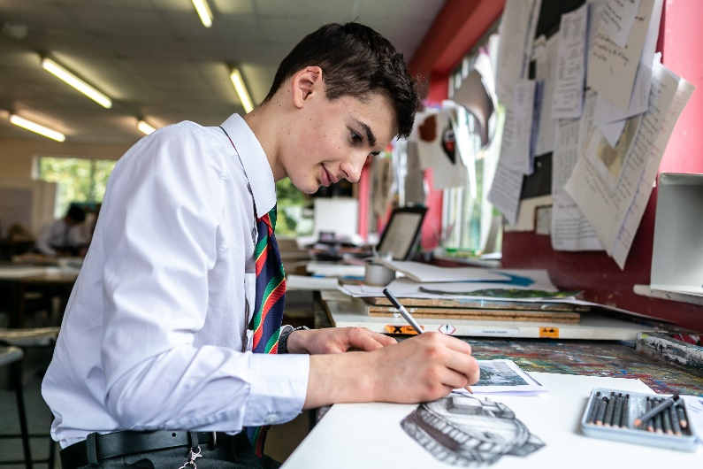

Core School Operations
Co-Curricular
Aspect | Update | Phase Review
House System  - Will remain for allocation of housepoints  Sport  - These will be by extended ‘bubble’ i.e. U15, U9  Music  - Reconfigure pastoral spaces to minimise contacts and mixing  Trips  - Day trips may be possible  Creative  - Running most Drama, Art and DT activities with adjustments for social distancing  Community and Speakers  - No activities until Phase 3 review | - No mixing of year groups within Houses  - No inter-house events  - Delivered via Lesson 3a/3b  - Appropriate curriculum to reflect APE/Sport governing body guidelines  - Structured theory lessons  - Peripatetic lessons with visiting staff using PPE  - Nature of venue/COVID-19 precautions/curriculum relevance will all be assessed  - Appropriate cleaning for bubble changeovers  - pupils and staff are mixing in a consistent group only, i.e. a ‘super bubble’ which excludes parents and visitors | - Phase 3 review  - Phase 2 review  - Phase 2 review  - Phase 1 review  - Phase 2 review  - Phase 1 review  - Phase 3 review

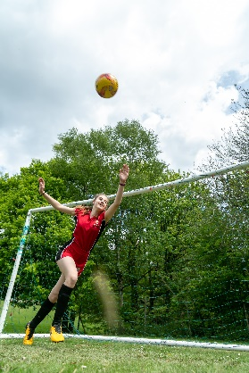
Core School Operations
Hygiene and Safety
Aspect | Update | Phase Review
Hand Sanitation  - Increased provision  Face Masks  - No requirement for pupils to wear masks on site, but essential for minibus/public transport  Traffic Flow and Social Distancing  Checks and Testing  - Boarding  Medical Centre  - COVID-19 tracking and awareness control centre | - Extra stations at key entry/exit points and curriculum/pastoral areas  - Signage and staff supervision  - Face masks on site will be permitted for those that choose to wear them  - All pupils should carry a resealable plastic bag to store the face mask  - Prep and Senior School start times to be coordinated  - Increased Signage  - Staff supervision  - Internal arrangements for boarding pupils  - Reconfiguring for COVID-19 preparedness  - Increase PPE supplies  - Strong contact with local GP Surgery and other authorities | - Phase 1 review  - Phase 1 review  - Phase 2 review  - Phase 1 review  - Phase 1 review

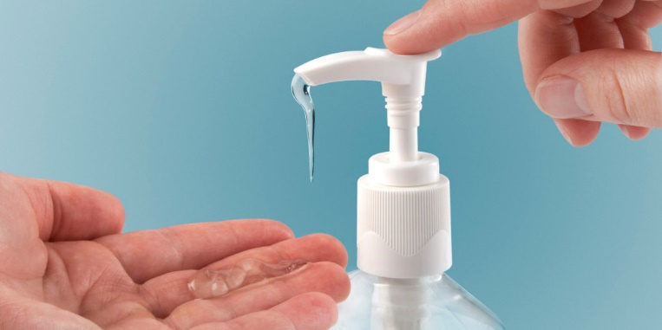

Core School Operations
Parents and Visitors, and Overseas Support
Aspect | Update | Phase Review
Parents  - Revising arrangements for parents visiting the school  PA Shop  - Retain but reduce regularity of opening  Visitors  - Keeping external visitors and events to a minimum  Prospective parents  - Revising arrangements for prospective parents  Communication  - Communicating separately and directly with overseas parents  Quarantine  - Offering Quarantine arrangements should this be required  School Holidays  - No school events, activities or lettings  Guardians  - Asking overseas parents to confirm that robust guardian arrangements are in place as normal. | - The school may be opened to visitors in phases  - Communications by phone/e-mail in the first instance  - Only one person in the shop at any time, facemasks to be worn, no access to other parts of the school site  - Initially, no visitors to the school unless related to H&S and essential maintenance  - Open events for parents will be held remotely  - Increased importance of website and ParentMail as sources of information  - Quarantine space and measures in place in Boarding  - Alternative provision for boarders  - School in regular contact with overseas parents and guardians | - Phase 2 review  - Phase 2 review  - Phase 2 review  - Phase 2 review  - Phase 1 review  - Phase 1 review  - Phase2 review  - Phase 2 review

This handbook has been compiled to reflect the specific procedures and considerations that Beechwood needs to follow based on the UK Government advice for the re-opening of schools for September 2020 that was published on the 2nd July.
The key principles from the DfE publication “What parents and carers need to know about early years providers, schools and colleges in the autumn term, Updated 31 July 2020” are:
- It is vital that children and young people return to school and college - for their educational progress, for their wellbeing, and for their wider development.
- School and college attendance will again be mandatory from the beginning of the new academic year.
- For parents and carers of children of compulsory school age, this means that the legal duty on you as a parent to send your child to school regularly will apply.
In compiling this guide, certain assumptions have been based on the CURRENT government position on school re-opening:
- UK Government guidelines will permit all pupils to return to school.
- Social distancing guidelines for pupils remain set at 1m.
We will continue to monitor and follow all guidance as it emerges and will adjust, and recommunicate, this plan as necessary.

