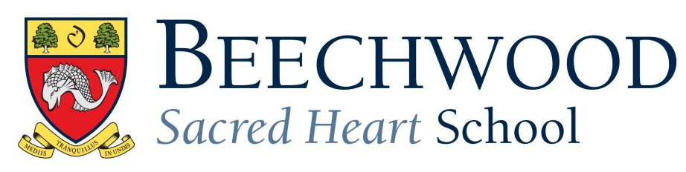
A Level Results 2020
 | A* | A | B | C | D | E | U | Total
Art | 0 | 2 | 1 | 0 | 0 | 0 | 0 | 3
Biology | 0 | 0 | 1 | 4 | 3 | 1 | 0 | 9
Business Studies | 1 | 1 | 2 | 1 | 0 | 0 | 0 | 5
Classical Civilisation | 2 | 0 | 0 | 0 | 0 | 0 | 0 | 2
Chemistry | 0 | 1 | 0 | 2 | 0 | 1 | 0 | 4
Chinese | 0 | 3 | 0 | 0 | 0 | 0 | 0 | 3
Computer Science | 0 | 1 | 0 | 1 | 0 | 0 | 0 | 2
Drama | 3 | 3 | 2 | 0 | 0 | 0 | 0 | 8
Product Design | 0 | 0 | 0 | 1 | 1 | 1 | 0 | 3
English | 0 | 2 | 1 | 0 | 0 | 0 | 0 | 3
Further Maths | 0 | 1 | 1 | 0 | 0 | 0 | 0 | 2
Geography | 0 | 0 | 2 | 0 | 0 | 0 | 0 | 2
History | 0 | 0 | 2 | 2 | 0 | 0 | 0 | 4
Mathematics | 2 | 2 | 1 | 2 | 1 | 1 | 0 | 9
Media Studies | 0 | 1 | 0 | 0 | 0 | 0 | 0 | 1
Physics | 0 | 1 | 1 | 1 | 0 | 1 | 0 | 4
Psychology | 0 | 0 | 2 | 1 | 0 | 0 | 0 | 3
Photography | 1 | 1 | 0 | 0 | 0 | 0 | 0 | 2
Russian | 1 | 0 | 0 | 0 | 0 | 0 | 0 | 1
Spanish | 0 | 0 | 0 | 0 | 0 | 0 | 0 | 0
Textiles | 0 | 2 | 0 | 0 | 0 | 0 | 0 | 2
EPQ | 3 | 2 | 3 | 0 | 0 | 0 | 0 | 8
Total (with EPQ) | 13 | 23 | 19 | 15 | 5 | 5 | 0 | 80
Total without EPQ | 10 | 21 | 16 | 15 | 5 | 5 | 0 | 72
 |  | No EPQ | All |  | Boys |  | Girls
 |  | A* | 14% |  | 0% |  | 26%
 |  | A*/A | 43% |  | 26% |  | 58%
 |  | A*/B | 65% |  | 53% |  | 76%
 |  | A*/C | 86% |  | 88% |  | 84%
 |  | A*/D | 93% |  | 91% |  | 95%
 |  | A*/E | 100% |  | 100% |  | 100%

